## Jamie Kirk Personal Portfolio – n9014390

### Artifact 1 (Back end development)

The majority of the back end development has been overseen and developed by myself with some assistance from Zach. Zach has handled the majority of the front end development with some assistance with integration from me.

The Google App engine played a large role in the development of back end services.

### Artifact 2 (User testing)

I assisted in the development of the user testing for the project. This role accompanied the development role due to the changes being made in the code requiring constant testing to ensure the projects functionality. This testing was provided in the early stages of development with Malavika developing the testing platform to perform the more repetitive tasks.

### Artifact 3 (User stories)

I along with the rest of team helped developed the user stories. Wanting to help with the development from the start assisted me in providing tasks to the stories that the team came up with. With the tasks being developed for each of the user stories the release and sprint plans were easily formed from this list of tasks.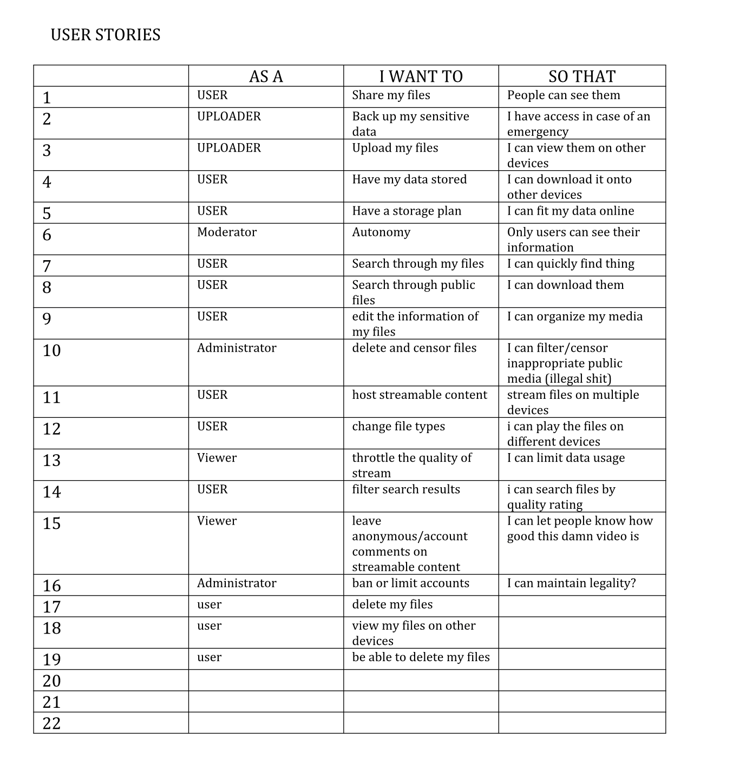

### Artifact 4 (Upload/Download integration)

Integration of the front end upload/download buttons into the back end file system. This involved the coding and back end controls for different users and files. This is currently being stored in Googles Big data hosting service.

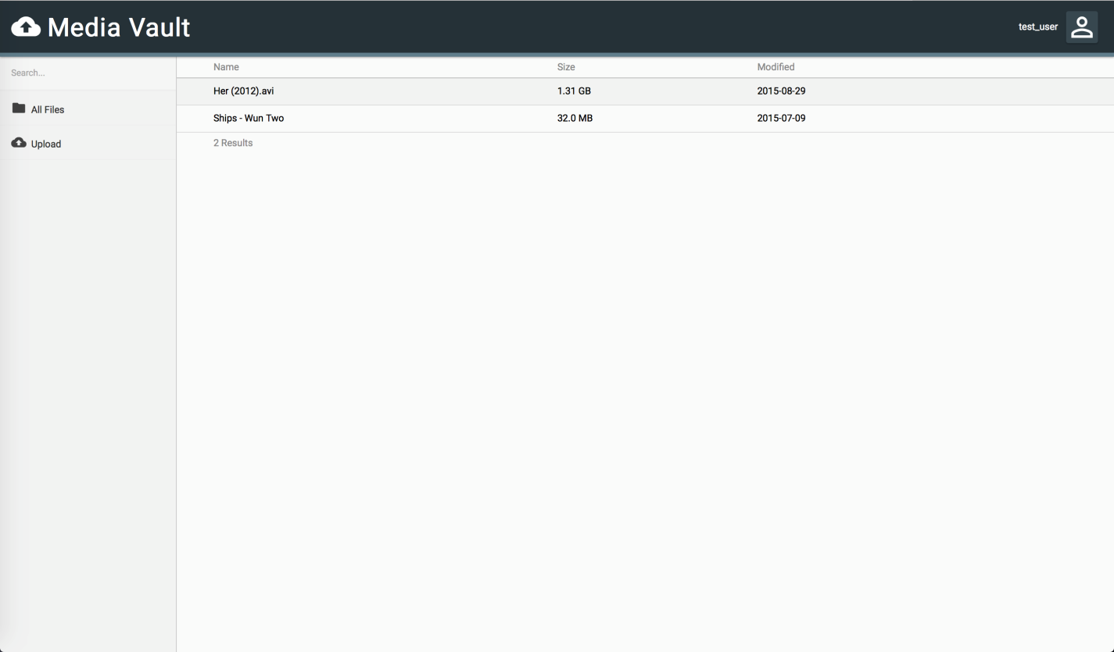

### Artifact 5 (MySQL backend)

The MySQL database which is associated with the login screen was migrated from the local database to one stored in the google cloud. This had some major difficulties in migrations with the user requests and some security policies that google had in place but we eventually got round this by allowing certain networks into the database.

